第三屆「社創‧社區 4.0 比賽」
The 3rd Social Innovation. Community 4.0 Competition
解難方案計劃書Proposal

注意事項：
- 請沿用此計劃書範本，切勿增刪表格項目
- 中文計劃書字數﹕1000字內
- 字體及格式﹕單行距，字型選用新細明體，字型大小為12
- 整份計劃書可加插不多於8張圖片協助闡述解難方案
- 請以PDF檔案提交計劃書，文件名稱格式為 學校名稱_方案名稱_計劃書.pdf
- 檔案不可超過5MB
- 請於2021年3月3日(三) 下午5時正或之前，將PDF計劃書電郵至 sic4.0@hkcss.org.hk， 逾期提交將不予受理
- 作品詳細要求請參閱比賽詳情及細則，主辦機構保留最終裁決權

Points to Note:
- Please adopt this proposal template and do not alter items of the form
- English proposal should be limited to 1300 words
- Formatting requirement: single line spacing, font style Times New Roman with font size 12
- No more than 8 pictures can be attached to illustrate the idea
- Please submit in PDF format withfile name format: School name_Proposal name_Proposal.pdf
- The file size should not exceed 5MB
- Submit the PDF proposal to sic4.0@hkcss.org.hk on or before 3 March 2021 (Wed) 5:00pm, late submissions will not be accepted
- Please refer to Competition Details & Conditions for the requirements; the Organizer reserves the right of final decision in case of any dispute

隊伍資料 Team Information
學校名稱:  School Name: | (中文)：
 | (Eng):
隊員名稱:  Student Name:  *為隊長  Team leader | *(中文) | *(Eng) | (年級)
 | (中文) | (Eng) | (年級)
 | (中文) | (Eng) | (年級)
 | (中文) | (Eng) | (年級)
 | (中文) | (Eng) | (年級)
 | (中文) | (Eng) | (年級)
組別名稱:  Team Name: | (中文)：
 | (Eng):
解難方案名稱:  Proposal Name: | (中文)：
 | (Eng):
團隊照片 Team Photo
請提供隊伍合照以於比賽相關活動中識別參賽者之用。
Please provide a team photo for identification purpose during competition-related activities.
相片規格 Photo Requirment
格式 Format | jpeg ／ png
解像度 Resolution | 1024 x 768 或以上 or above
提交方法 Submission Method: | 加插於以下方格 及 將照片(原始大小) 上載至Google雲端 或 Microsoft One Drive 共用，並將連結貼於下方。（步驟可參閱短片提交指引)  a) Insert photo in the box below and upload the photo to Google Drive or Microsoft One Drive, and b) paste the share link.  (May follow the steps from Video Submission guideline)

a)
隊伍合照
Team Photo

b)
共用連結
Share Link

比賽題目Competition Topic
題目選擇 (北區社群三選一)
Topic choice (select only ONE topic from the below three communities)
婦女
Women
長者
Elderly
青年
Youth

計劃書內容 Proposal Content
簡介Abstract
請用中文200-250字及不多於300字的英文簡介解難方案
Please introduce your proposal with 200-250 words in Chinese AND no more than 300 words in English

此部份字數不計入計劃書1000字以內 The number of words in abstract would not counted in the overall 1300 words of the proposal
中文﹕

字數 / number of words:
English:

字數 / number of words:

Part I: 解難方案的可行性 Feasibility of the Proposal
- 方案針對的具體社群 Specific community addressed

縮窄範圍並具體化 (例：婦女區內就業機會)
Narrow down and be specific (e.g. Women job opportunities within neighbourhood)
字數 / number of words:
- 方案內容 Proposal details

如何回應社區需要﹖有什麼策略﹖具體操作如何﹖
How will the prototype respond to community needs? What is the strategy? How does it operate?
字數 / number of words:
Part II: 解難方案的創新性及獨特性Proposal Innovation and Uniqueness

與市場相似的項目比較，解難方案有什麼不同﹖
What is the niche or highlight of the prototypes when compares to other substitutes?
字數 / number of words:

Part III: 解難方案的社會效益Social Impacts

方案對北區社區和社群帶來的正面影響。社群如何從項目有所得益﹖如何透過項目令社群與社區連結﹖
Positive impacts to people or community of the North District. How will the community be benefited? How will it facilitate the connection within communities?
字數 / number of words:
Part IV: 提交短片共用連結 Submission of Video Sharable Link

(請參閱「短片提交指引」 Please refer to “Video Submission Guideline”)
Google / Microsoft One Drive共用連結sharable link：

______________________________________________________________________________
*請確保連結已開啟共用功能
*Please ensure the link is shared (Link sharing on)

第三屆「社創‧社區 4.0 比賽」
短片提交指引

短片規格
- MP4格式
- 長度限於三分鐘之內
- 檔案不可大於100MB
- 形式不限，如動畫、微電影、slideshow等均可
- 語言中英皆可

短片須包含
- 方案針對的社群
- 方案的設計理念及運作
- 解釋方案如何幫助社群發展及需要

提交方法
上載短片至Google雲端 或 Microsoft One Drive，將共用連結放於解難方案計劃書中的Part IV。
Google 雲端
上載短片至Google雲端，選擇「取得檔案共用連結」 (紅圈)，確保「連結共用設定」已轉為綠色「已開啟」(藍圈)，複製連結，並將連結拼貼於解難方案計劃書中的Part IV。
Microsoft One Drive
上載短片至Microsoft One Drive，選擇「共用」及複製連結 (紅圈)，確保「擁有連結的任何人都可以編輯」 (藍圈)，複製連結，並將連結拼貼於解難方案計劃書中的Part IV。

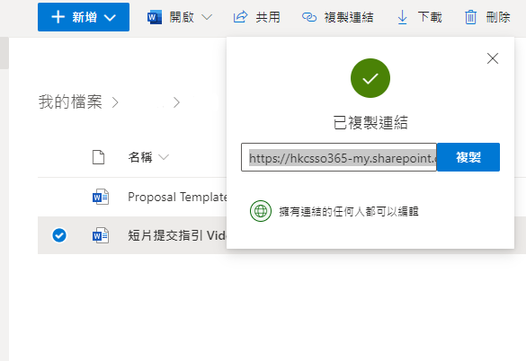
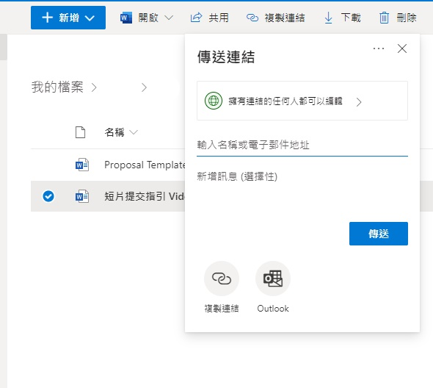
Video Submission Guideline

Video Format
- MP4 format
- No longer than 3 minutes
- No larger than 100MB
- Various video styles are welcomed, animation, micro movie, slideshow etc.
- Language: Cantonese or English

Video Content
- The Community addressed
- Design concept and operation of the proposal
- How can the proposal address the community needs and development?

Submission Method
Upload to Google Drive or Microsoft One Drive and paste the link in Part IV of the proposal.

Google Drive
Upload the video to Google Drive, right click the video and select “Get shareable link” (red circle). Ensure “Link sharing on” and the button turns green (blue circle), then “copy link”. Lastly, paste the video link in Part IV of the proposal.

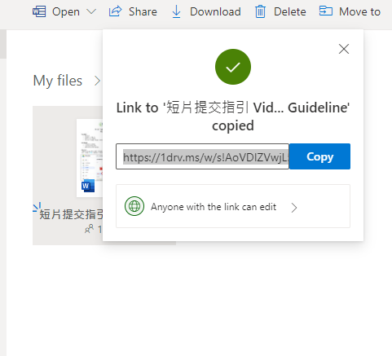
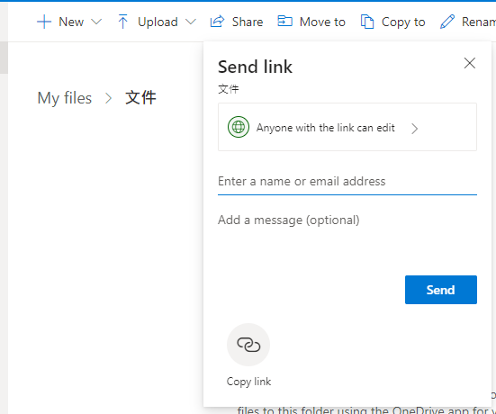
Microsoft One Drive
Upload the video to Microsoft One Drive, right click the video and select “Share” and “Copy Link” (red circle). Ensure “Anyone with the link can edit” (blue circle), then “Copy”. Lastly, paste the video link in Part IV of the proposal.

