短片提交指引

短片規格
- Mp4格式
- 長度限於三分鐘之內
- 檔案不可大於100MB

短片須包含
- 原型方案針對的社區問題
- 原型的設計理念及運作
- 解釋原型如何改善社區問題
形式不限，如動畫、微電影、slideshow等，唯清晰表達及創意將影響評分

提交方法
上載短片至Google雲端，於「連結共用設定」選擇「任個擁有連結的人均可以編輯」(橙圈)，複製連結 (藍圈)，並將連結拼貼於原型方案計劃書中(Part IV)一併提交。

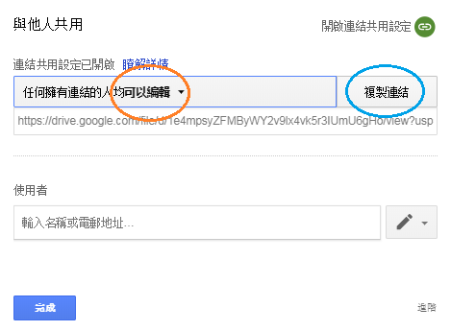

Video Format
- Mp4
- No longer than 3 minutes
- No larger than 100MB

Video Content
- The community problem the prototype focused on
- The design concept and operation of the prototype
- How can the prototype resolve the community problem?

No requirement on video styles. Animation, micro film, slideshow, etc. are all acceptable.
Clarity and creativity shall be considered for rating.

Submission Method
Upload the video to Google Drive, right click the video and select “Share…”. Select “Anyone with the link can edit” (Orange Circle), then “copy link” (blue circle). Lastly, submit the Prototype Proposal (Part IV) with the link included.

